Lab - Create User Accounts

## Creating a New Local User Account

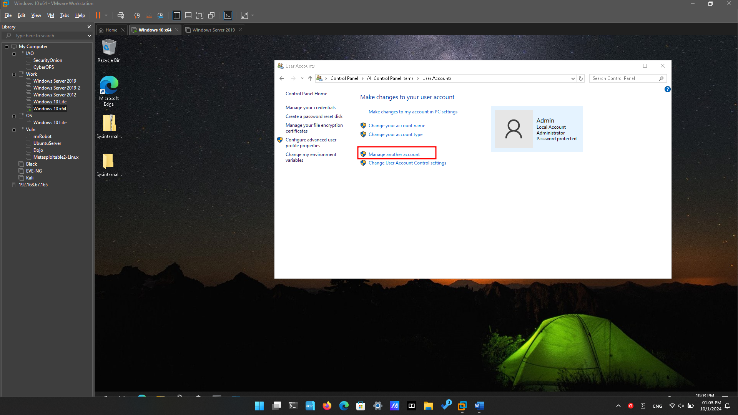

Click on “Manage User Accounts”

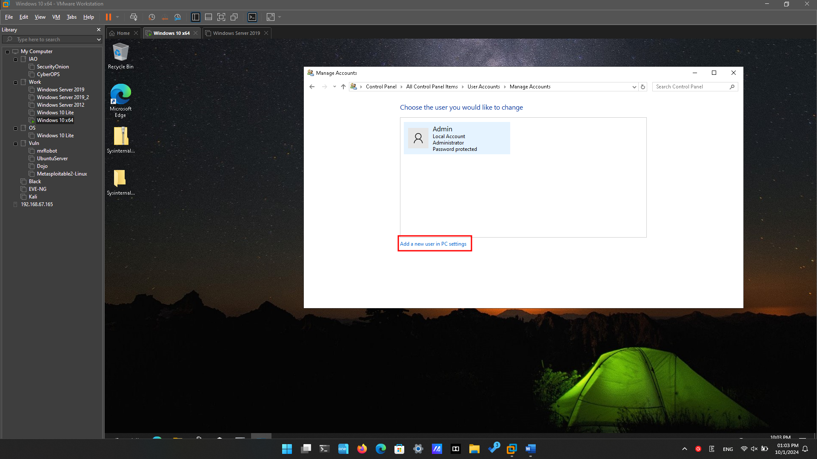

Click on “Add a new user in PC settings” to add user

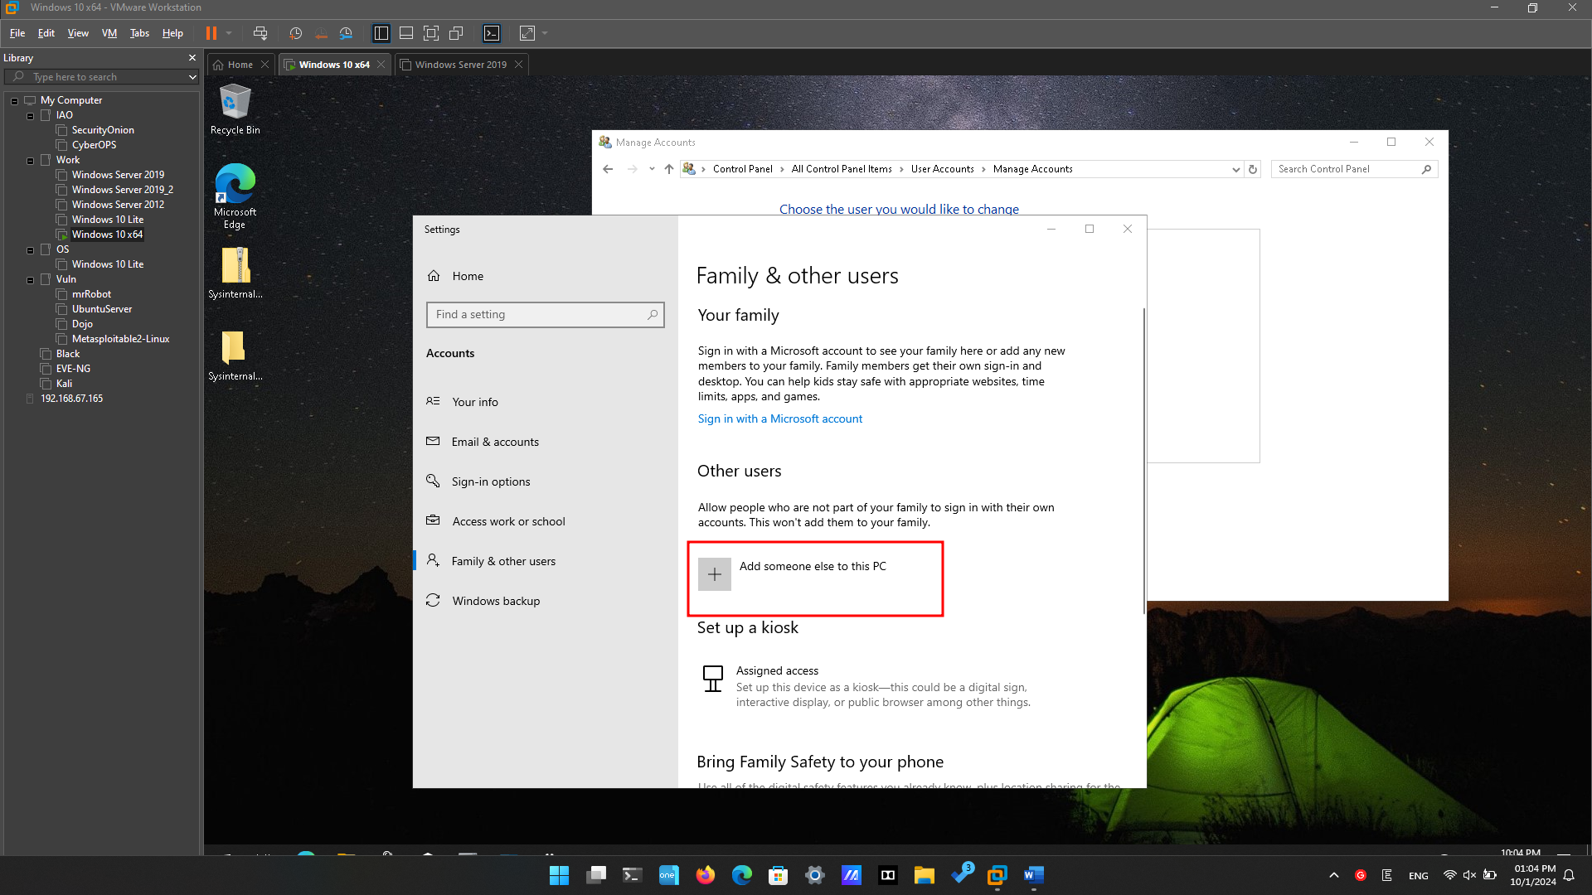

Click “Add someone else to this PC”

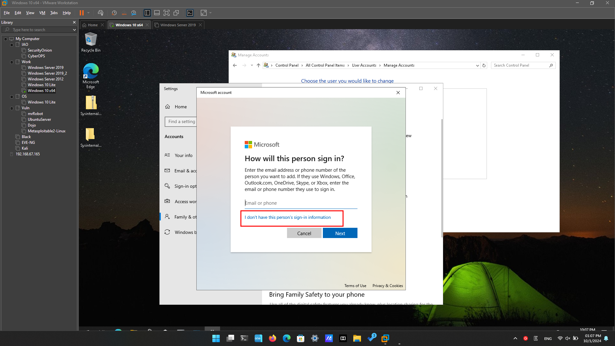

We only want to add a local account – without Microsoft account so click “I don’t have this person’s sign-in information”

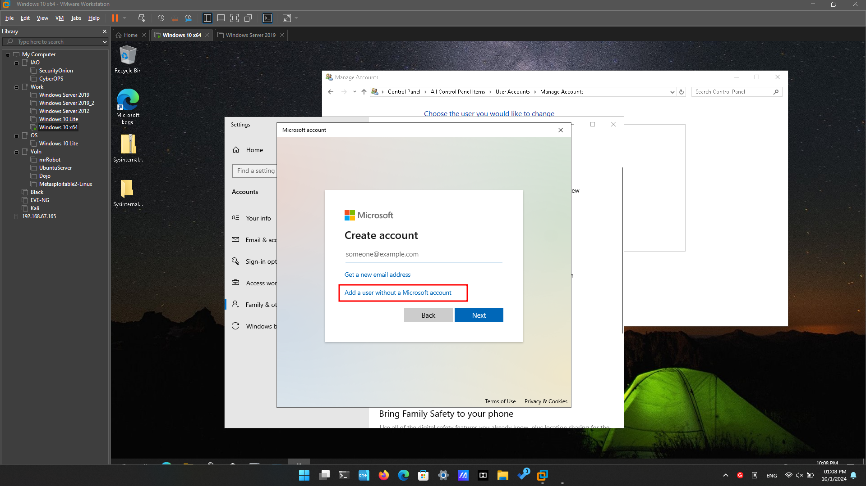

Click “Add a user without a Microsoft account”

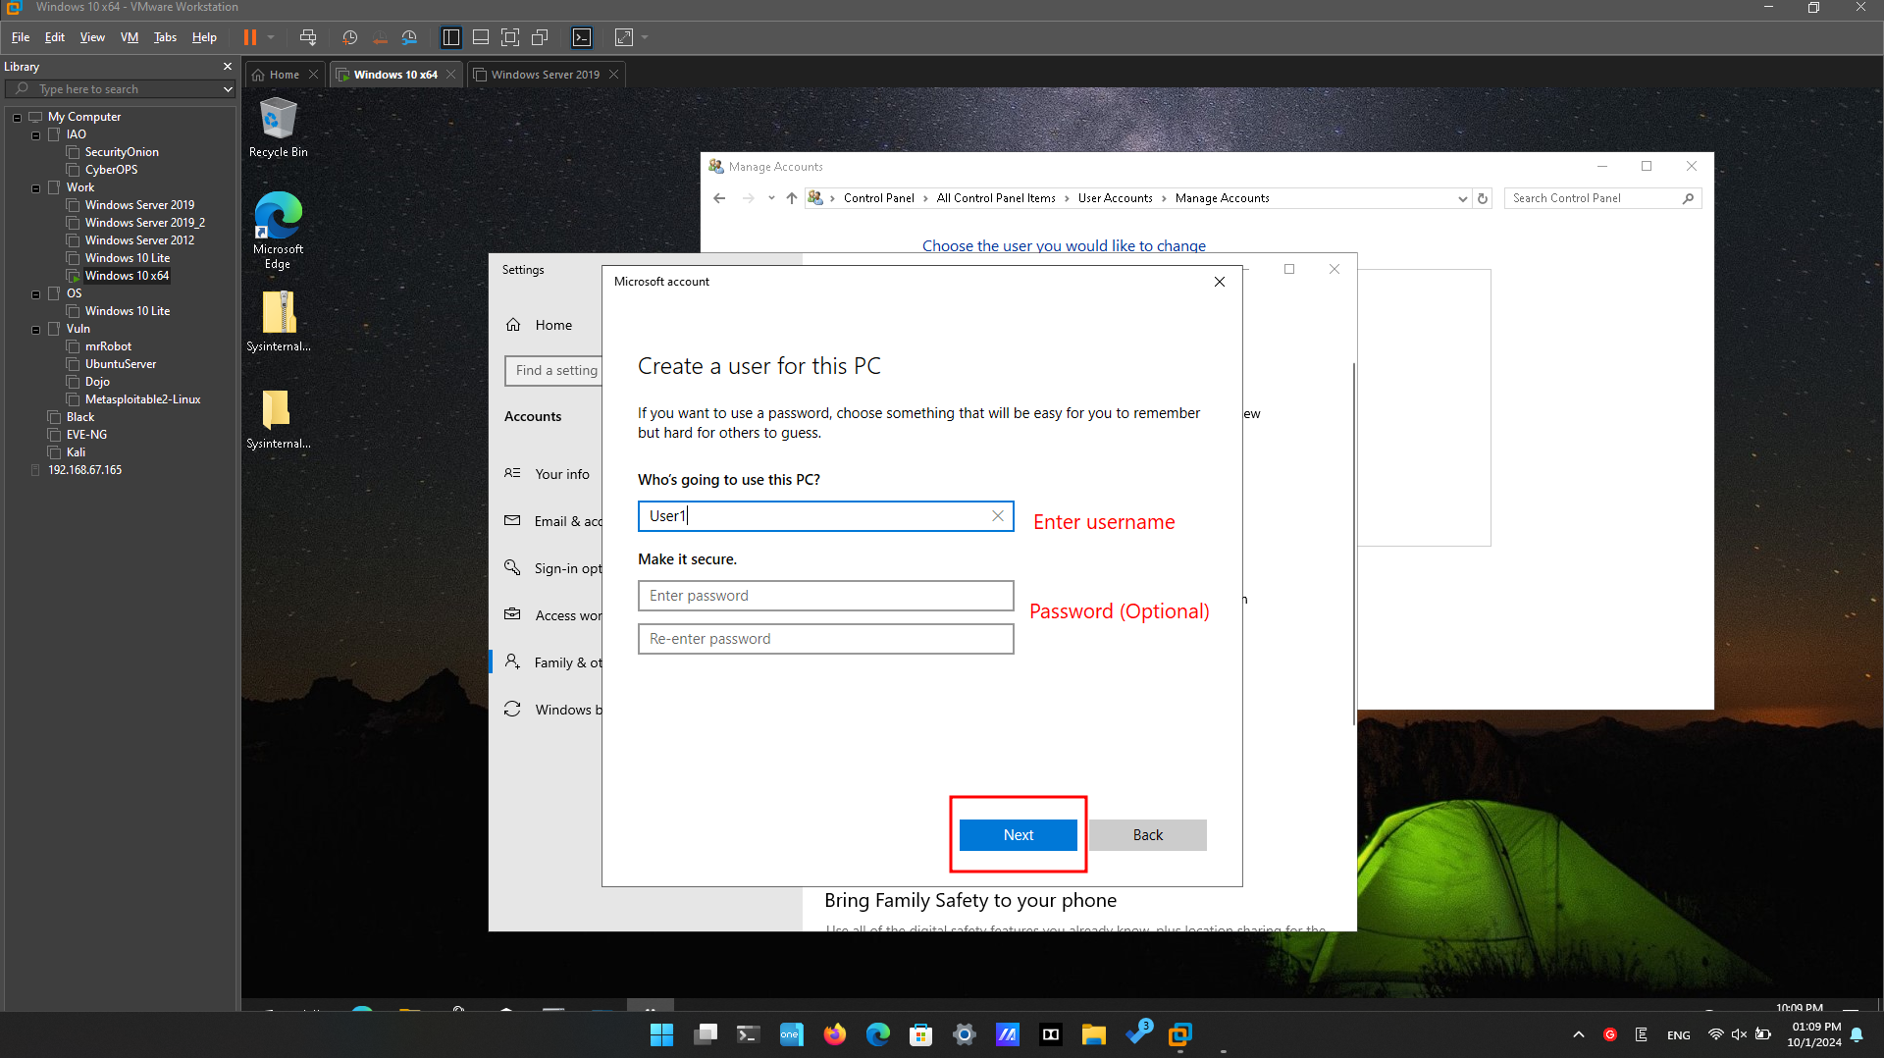

Enter the “Username” and the password (optional) for user.

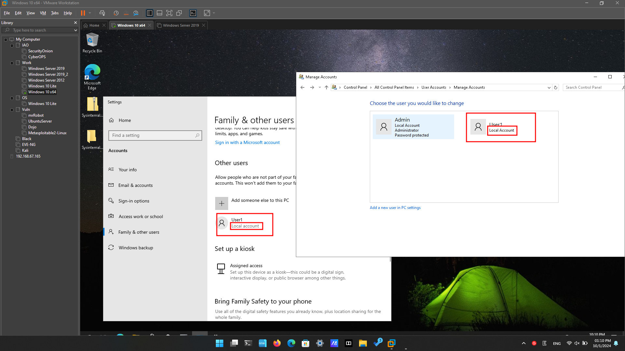

What type of user account did you just create?

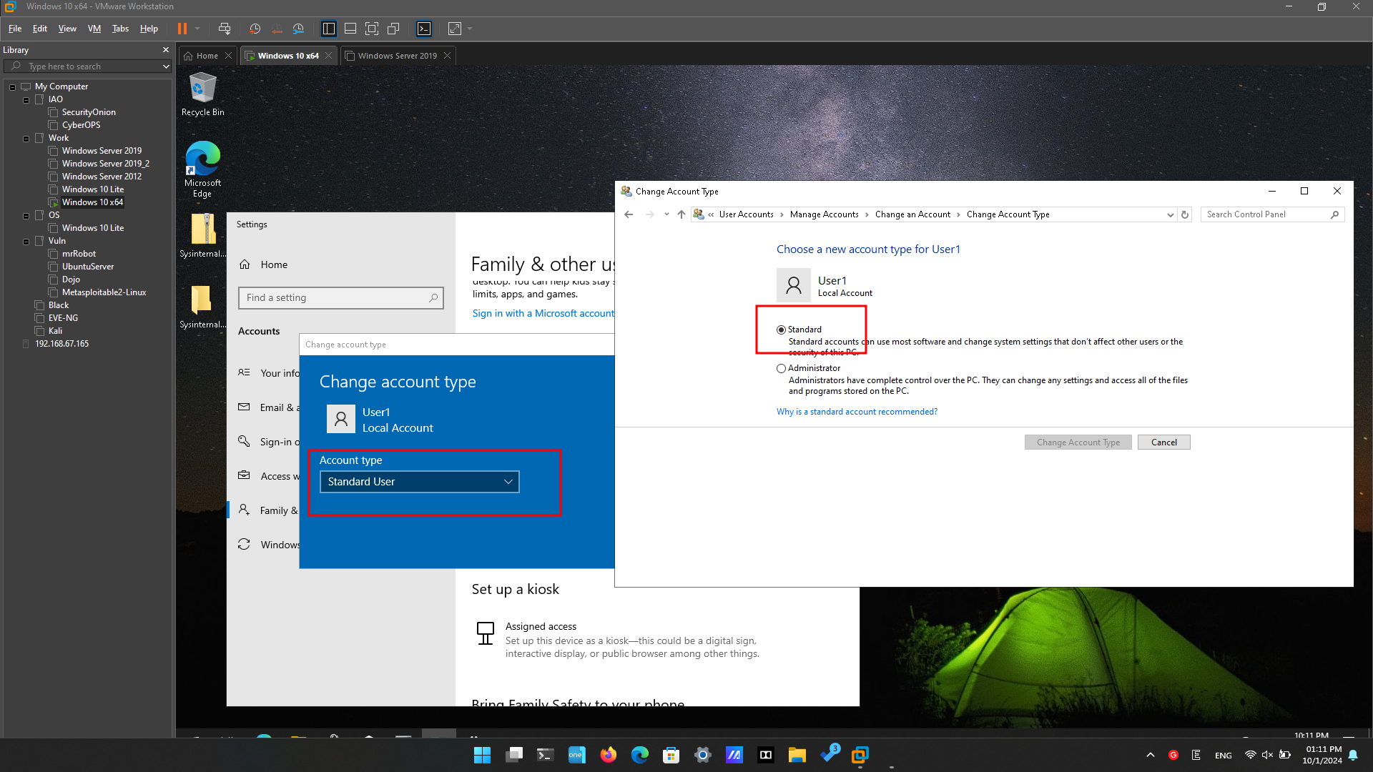

Local Account – Standard Account

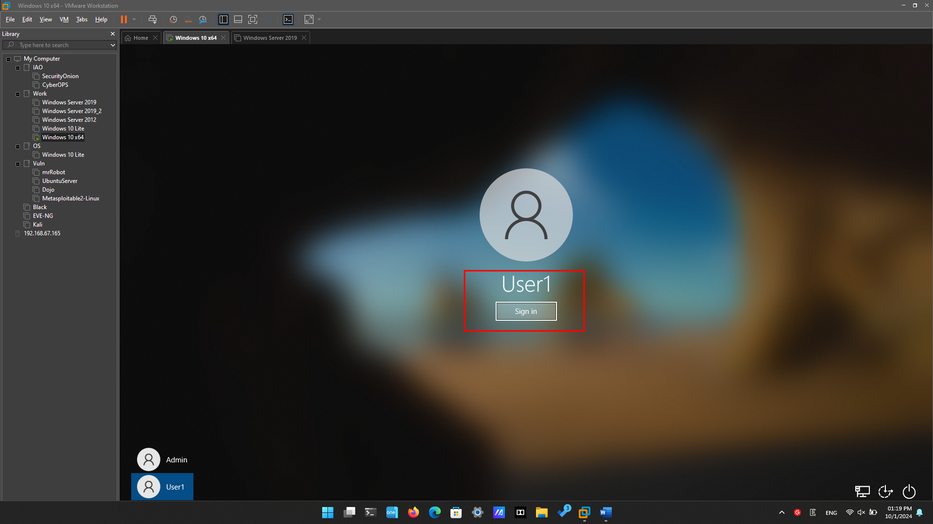

Click Sign in (enter password if necessary)

Folder C:\Users\User1. Which groups or users have full control of this folder?

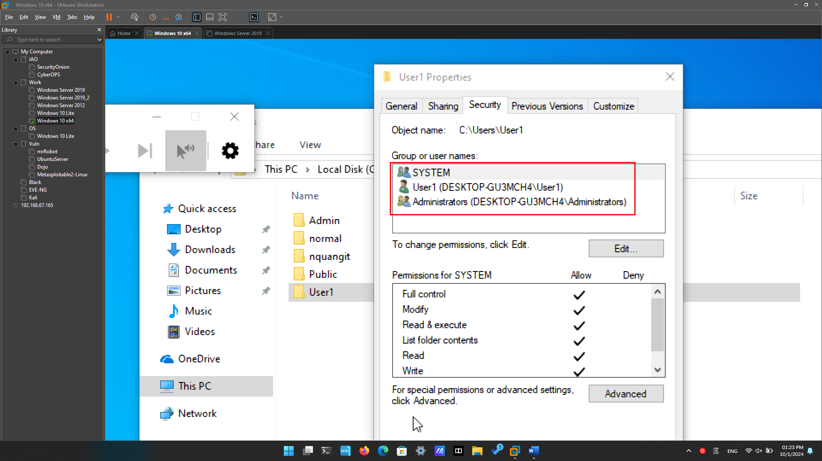

SYSTEM, User1, Administrators

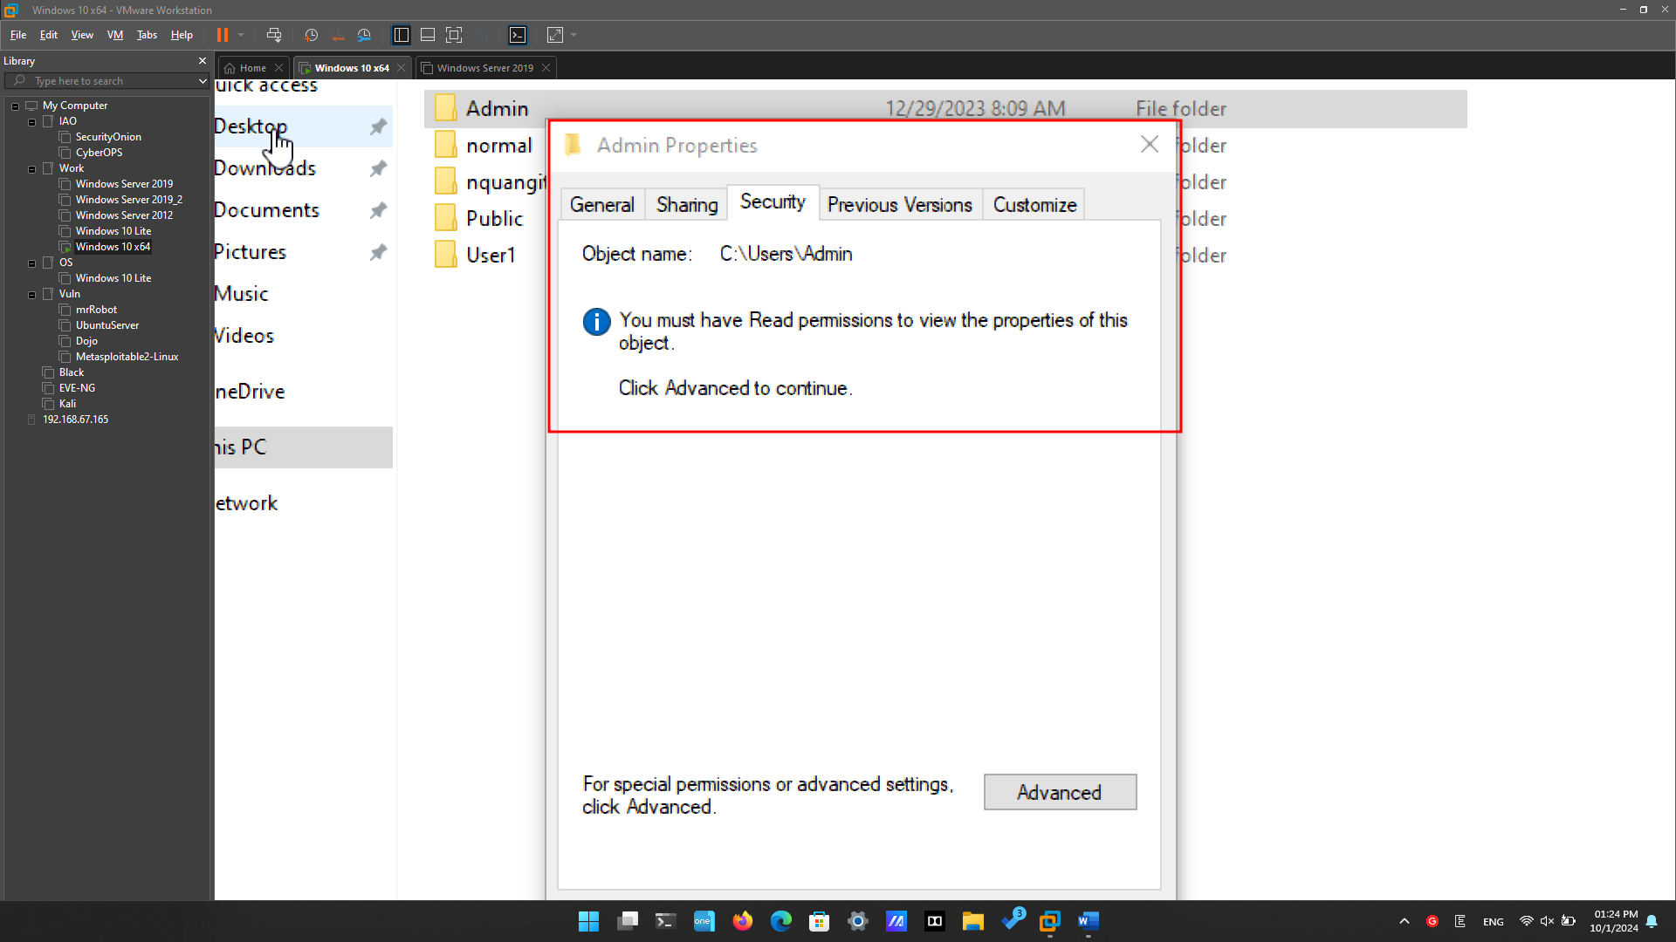

Were you able to access the folder? Explain.

User1 can not access the folder C:\Users\Admin.

**Admin** is an account that is in the Administrators group – or Administrator Account Type.

But **User1** is only a Standard Account that does not have permission to perform any action to another account or Administrators account.

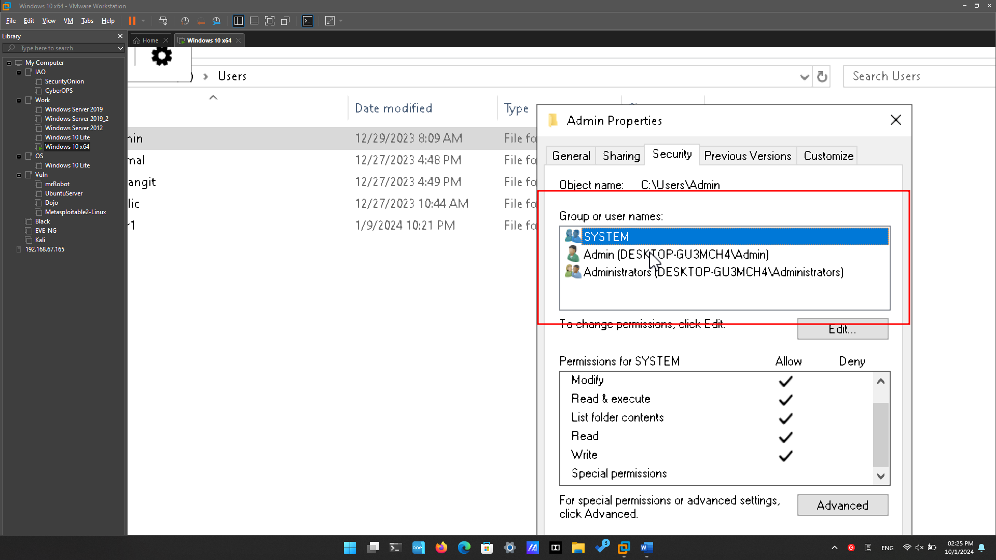

Folder C:\Users\Admin. Which groups or users have full control of this folder?

SYSTEM, Admin, Administrators

## Reviewing User Account Properties

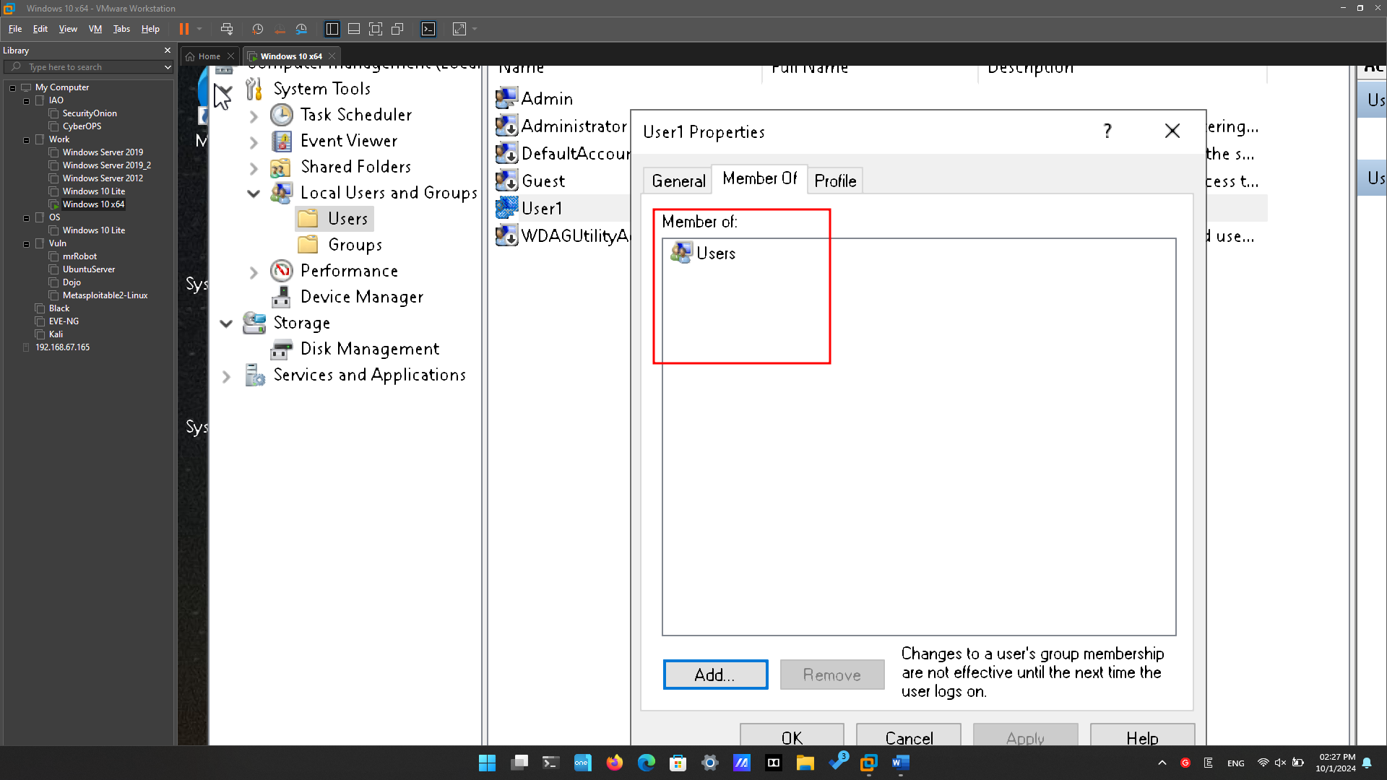

Which group is User1 a member of?

**User1** is a member of: Users group.

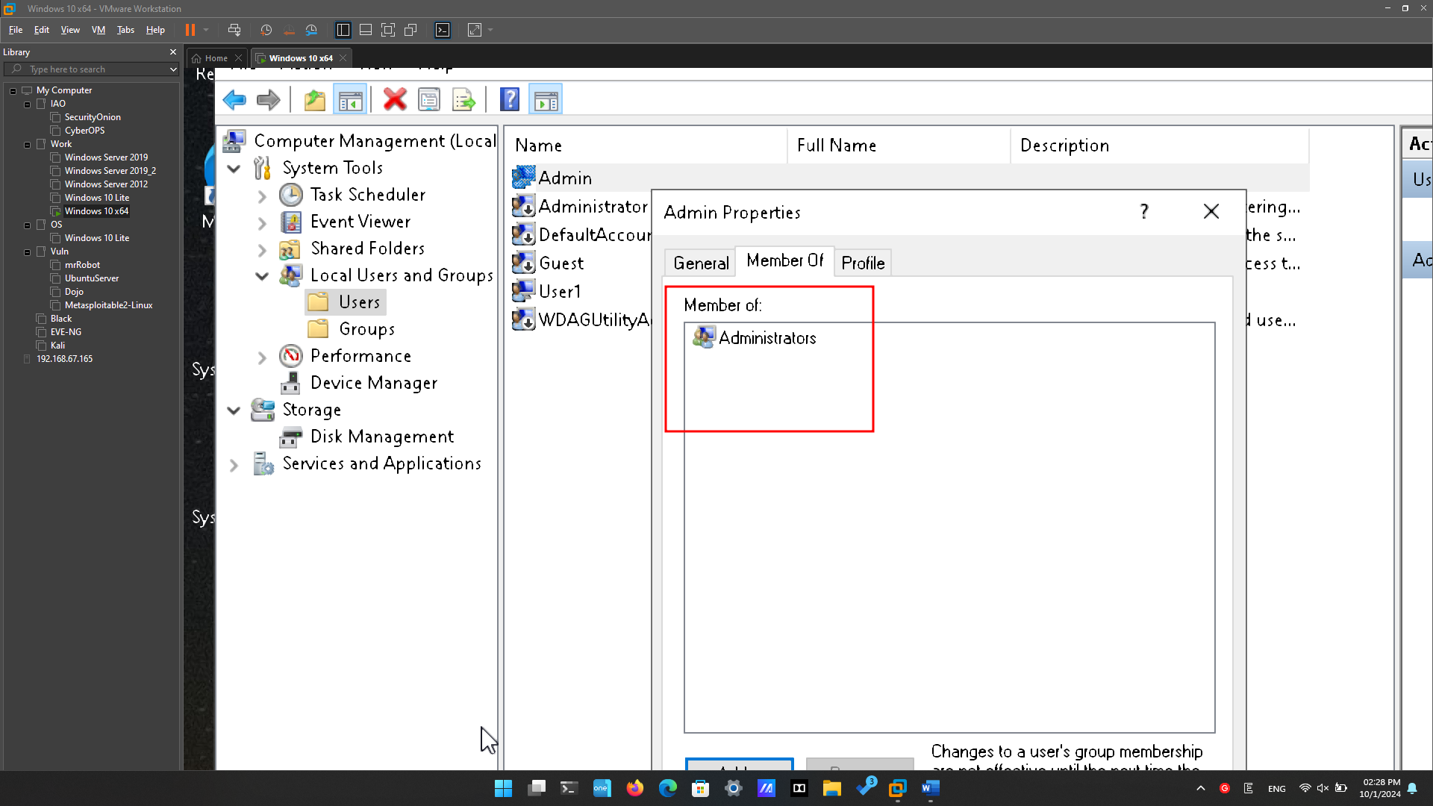

Which group is this user a member of?

User Admin (CyberOpsUser) is a member of: Administrators group.

## Modifying Local User Accounts

### Change the account type.

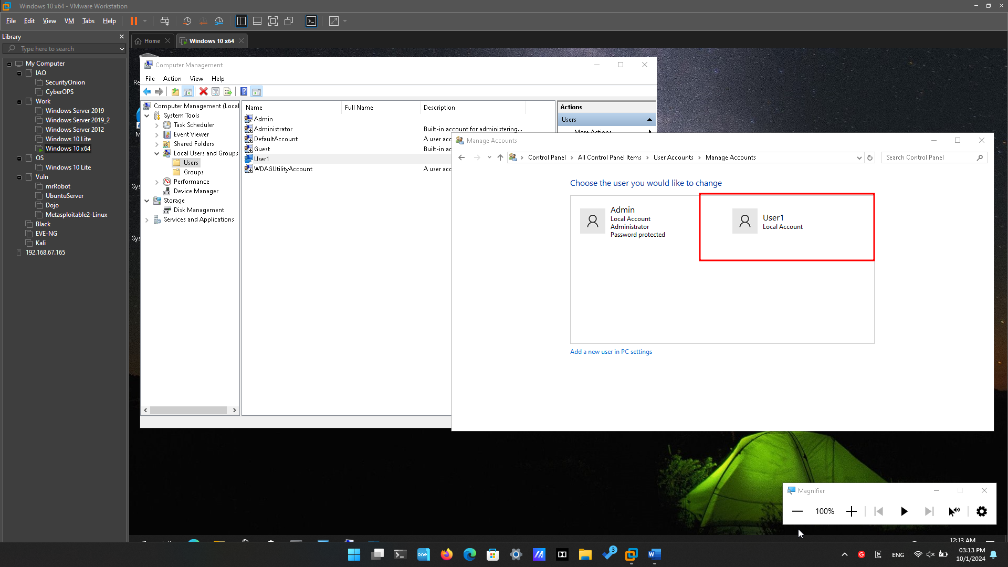

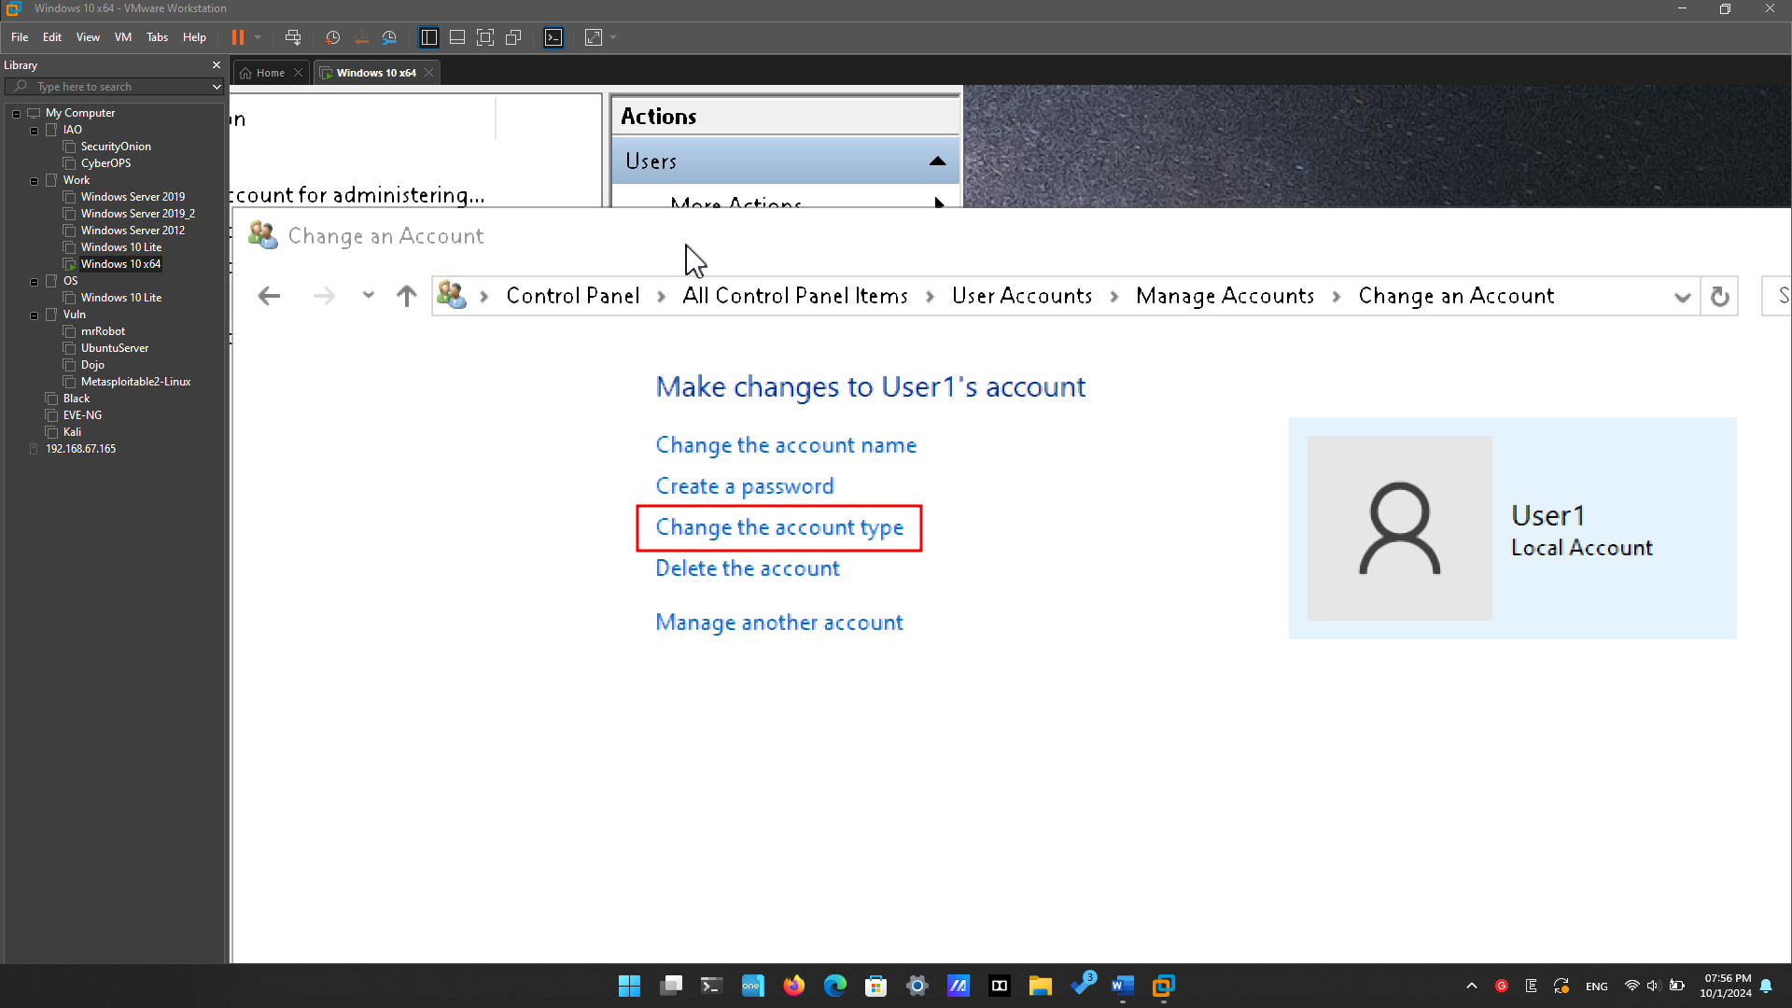

Select “Change the account type” to change account type for “User1”.

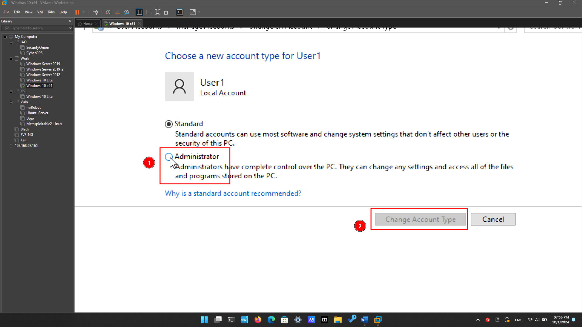

Choose “Administrator” type and the button “Change Account Type” will be enabled, click to save.

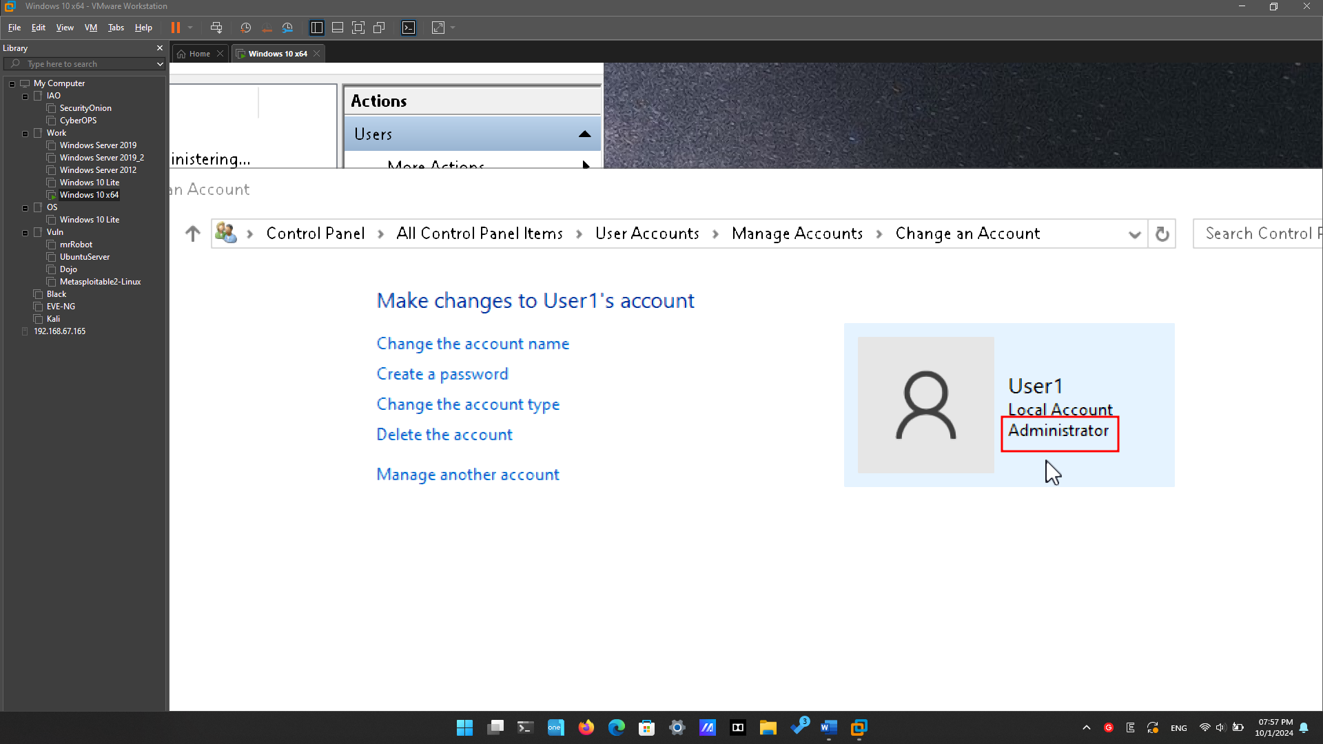

We can see that user “User1” is now an Administrator account.

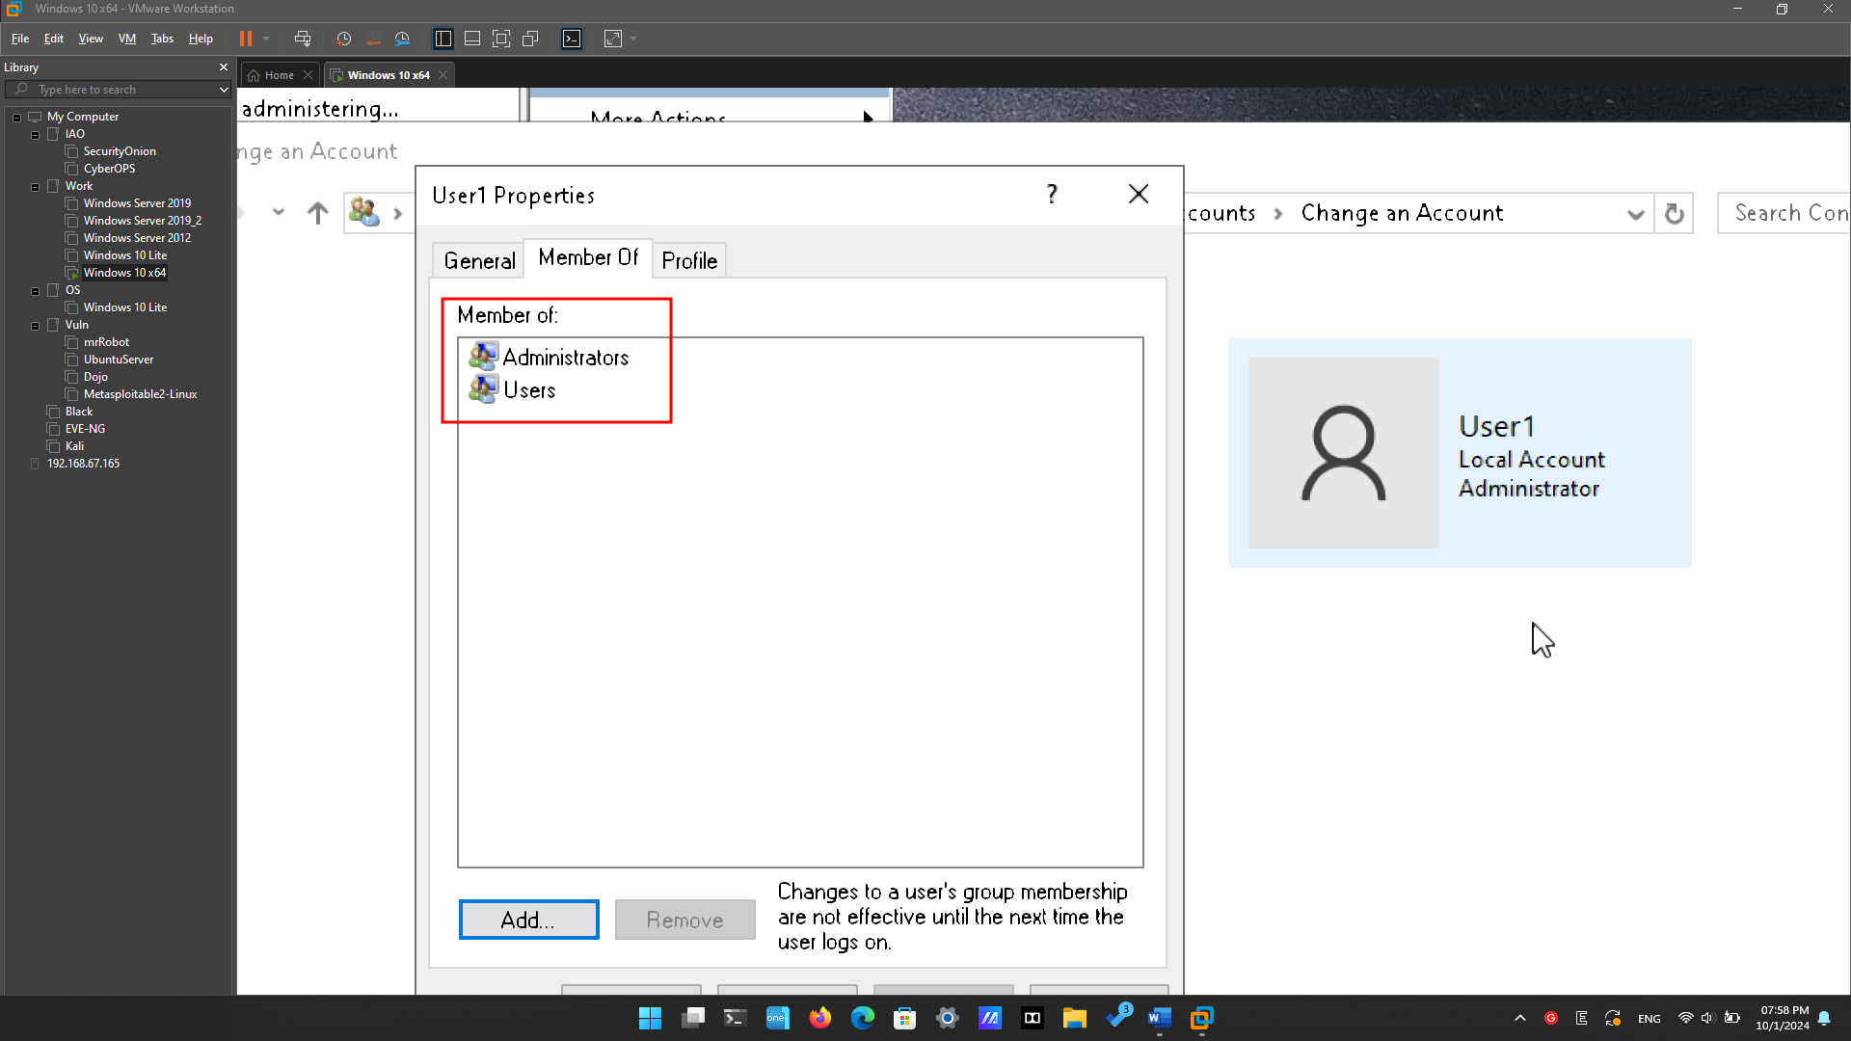

Which groups does User1 belong to?

After changing the Account type of User1 to Administrators. User1 became a member of Administrator group and Users group.

### Delete the account.

What is another way to delete a user account?

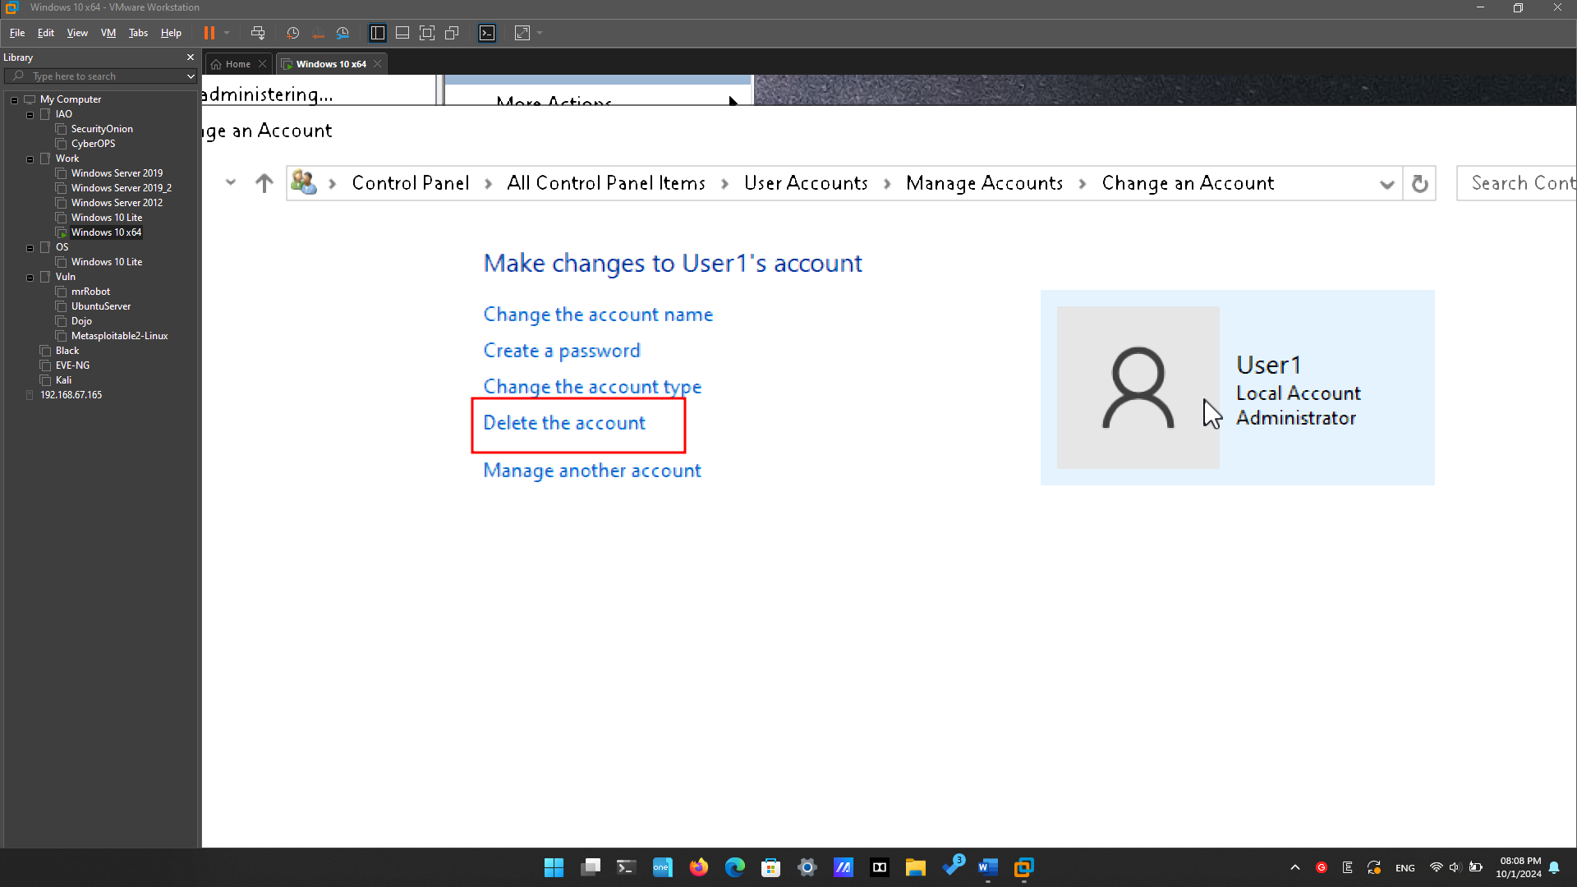

Go to the “Manage Account” in the Control Panel with Administrators. Click “Delete the account”. 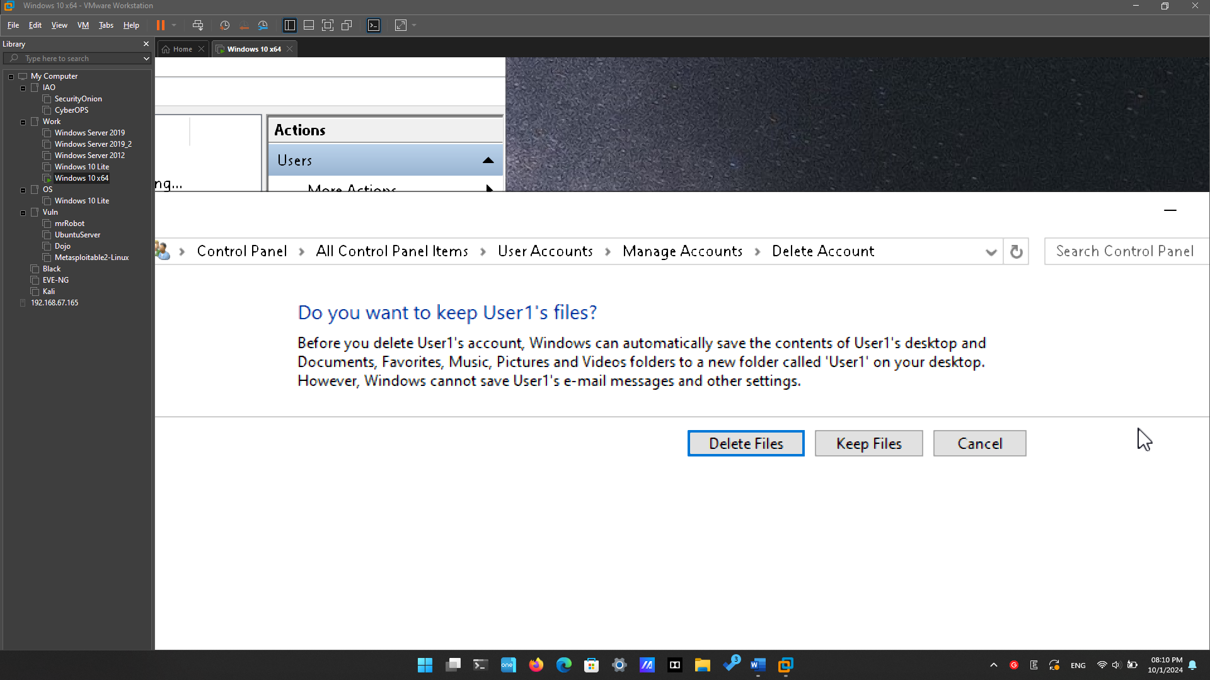

And it will show you if you want to keep user’s file or not. Click “Delete Files” or “Keeps Files”.

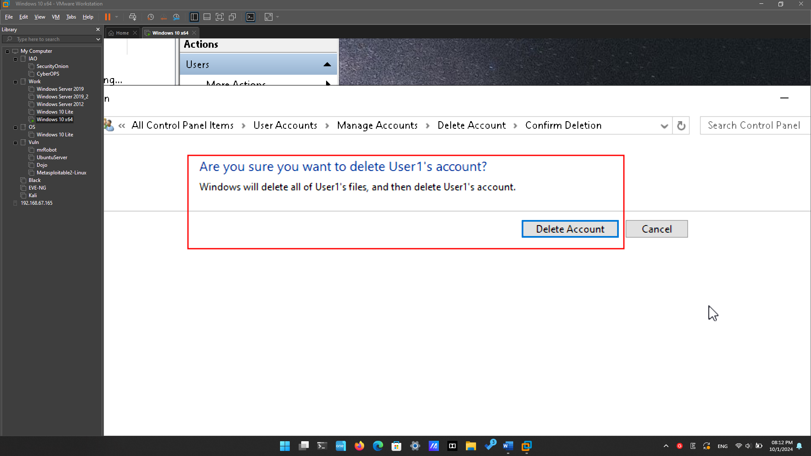

Then it will ask for submission. Click “Delete Account” to submit.

# Reflection Questions

* 1. Why is it important to protect all accounts with strong passwords?

The absence of a password or the presence of a weak password can potentially grant access to unauthorized individuals, enabling them to compromise data or misuse the computer.

* 1. Why would you create a user with Standard privileges?

A Standard User does not have the capability to jeopardize the computer's security or infringe upon the privacy of other users.